The Sreenivasan Lab Coding Manual

Introduction to MATLAB

1. **Essentials:**

Before you start with MATLAB, there are some concepts that you should be comfortable with. Make sure you go through this document and its exercises in detail before continuing: [document](https://docs.google.com/document/d/1B8fmSGKMbAUSg5Mca5C2LhgBXAwN3rxF_BYQPD-uJ00/edit?usp=sharing)

1. **Lynda (**[**www.lynda.com**](http://www.lynda.com/)**)**

A great resource for beginners is Lynda. As part of NYU you have complete access to the website and the hundreds of videos on their website.

Go to the website and click “Sign In” in the top right corner.

This will bring you to the sign in page.   
Click “Sign in with your organizational portal”

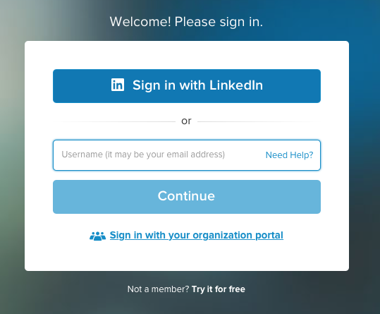

Enter “nyu.edu” in the organization’s URL

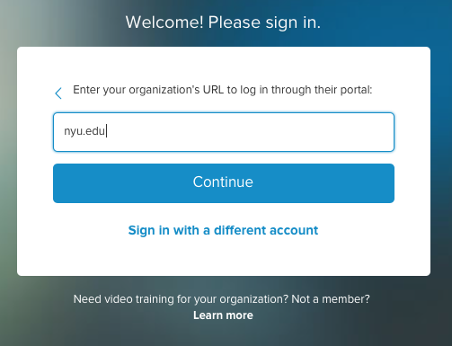

This will bring you to the university’s sign in portal.

Use your netID and password to access the website.

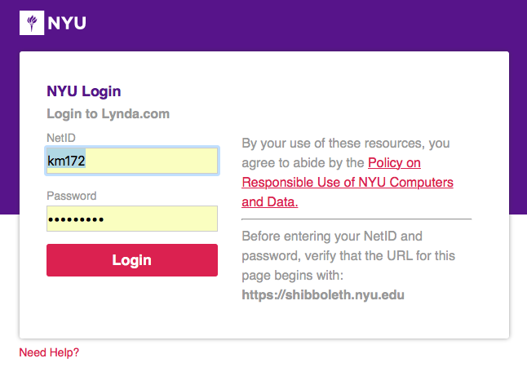

A helpful tutorial that will introduce you to the basics of coding can be found here: [link](https://www.lynda.com/Programming-Foundations-tutorials/Welcome/83603/90426-4.html?srchtrk=index%3a11%0alinktypeid%3a2%0aq%3aFundamentals+of+coding%0apage%3a1%0as%3arelevance%0asa%3atrue%0aproducttypeid%3a2)

A second tutorial titled “**Learning MATLAB**” is also helpful. You can either search for it in the library or follow [this link](https://www.lynda.com/MATLAB-tutorials/Up-Running-MATLAB/124067-2.html?org=nyu.edu).

1. **Youtube**

There are countless tutorials available on youtube, and you can navigate through them based on what you require more help with. Some good ones to start are:

* The Complete MATLAB Course: Beginner to Advanced! ([link](https://youtu.be/T_ekAD7U-wU))
* Complete MATLAB Tutorial for Beginners ([link](https://youtu.be/qGiKv3-02vw))

1. **Books**It may be old-fashioned, but it’s still one of the most reliable methods to learn. Some great books are:

* Beginner Level 🡪 Matlab for Neuroscientists by Pascal Wallisch
* Advanced Level 🡪 Matlab for Brain & Cognitive Scientists by Mike X Cohen

Introduction to Psychtoolbox

Most of our studies that are programmed on MATLAB use Psychtoolbox. The toolbox contains multiple functions that allow easy and precise presentation of stimuli.

It is really important that you familiarize yourself with some basic psychtoolbox functions and the best resource for doing so is Peter Scarfe’s website ([link](http://peterscarfe.com/ptbtutorials.html)).

Go over the tutorials provided on the website, and try running them and playing around with the code.